 | CS 249 Data Structures  L17 Worksheet  (Graphs)

Team
Record the names of students who worked together on this worksheet below.
Student name | Student ID

General Instructions
Step 1. Answer the questions below to strengthen your understanding of hashing-related concepts.
Step 4. Generate a PDF with your solution and submit it as the solution for this assignment.
- Consider an undirected graph with ten thousand vertices where each vertex has exactly 20 neighbors. What space in bytes is needed to represent the graph using:

  - an adjacency matrix, considering that the matrix is implemented as a 2D array of bits (1 bit per edge)

  - an adjacency list, considering that a node in the list contains a long integer value for the neighbor’s index and a pointer to the next neighbor. Assume long integers are 8 bytes long

  - Explain the reasons for the difference in memory performance, why is one representation more efficient than the other?

- Consider the following undirected graph. Represent this graph using adjacency matrix representation. You can fill in the cells with 1 when the edge is present and leave the remainder blank to represent the absence of edges.

 | 0 | 1 | 2 | 3 | 4 | 5 | 6 | 7 | 8 | 9 | 10 | 11 | 12 | 13 | 14 | 15
0
1
2
3
4
5
6
7
8
9
10
11
12
13
14
15

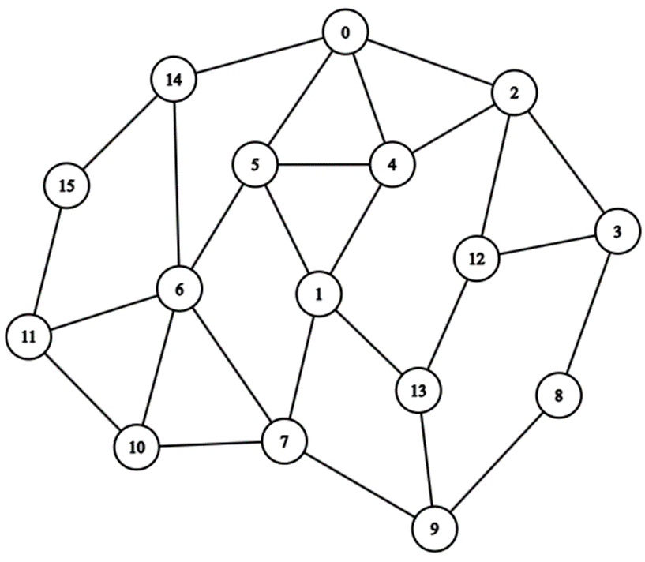

- Consider the undirected graph from Problem 2. Answer the following:
  - The size of the graph:
  - The maximum size of the graph:
  - The shortest path between 14 and 9:
  - The degree of vertex 6:
  - The BFS traversal order:
  - The DFS traversal order:
  - The neighbors of vertex 4:
  - The density of the graph (ratio between the number of edges and the maximum size of the graph):
  - The size of the graph if vertex 1 is deleted:
  - The maximum size of the graph if vertex 1 is deleted:

- Represent the undirected graph from Problem 2 using an adjacency list. To facilitate the representation, use the table below to store the nodes in your linked list. Cells with -- are considered empty memory. Follow the model.
0 | 2-> | 4-> | 5-> | 14-> | NULL | -- | --
1
2
3
4
5
6
7
8
9
10
11
12
13
14
15

- Consider the following directed graph. Represent this graph using adjacency matrix representation. You can fill in the cells with 1 when the edge is present and leave the remainder blank to represent the absence of edges. Pay attention to edges with two ends, they count as two edges (one incoming and one outgoing)!
 | 0 | 1 | 2 | 3 | 4 | 5 | 6 | 7 | 8 | 9 | 10 | 11 | 12 | 13 | 14 | 15
0
1
2
3
4
5
6
7
8
9
10
11
12
13
14
15

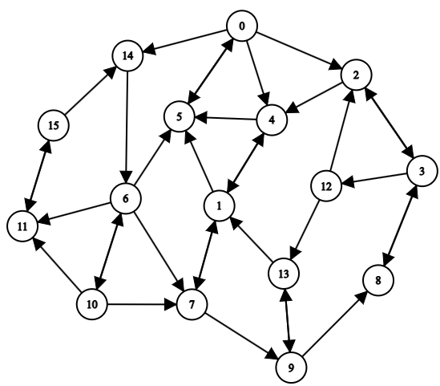
- Consider the undirected graph from Problem 2. Answer the following:
  - The size of the graph:
  - The maximum size of the graph:
  - The shortest path between 14 and 4:
  - The in-degree of vertex 6:
  - The out-degree of vertex 6:
  - The BFS traversal order:
  - The DFS traversal order:
  - The neighbors of vertex 4:
  - The density of the graph (ratio between the number of edges and the maximum size of the graph):
  - The size of the graph if vertex 1 is deleted:
  - The maximum size of the graph if vertex 1 is deleted:

- Represent the undirected graph from Problem 5 using an adjacency list. To facilitate the representation, use the table below to store the nodes in your linked list. Cells with -- are considered empty memory. Follow the model.
0 | 2-> | 4-> | 5-> | 14-> | NULL | -- | --
1
2
3
4
5
6
7
8
9
10
11
12
13
14
15

- Consider the following undirected weighted graph. Represent this graph using adjacency matrix representation.

 | 0 | 1 | 2 | 3 | 4 | 5 | 6 | 7 | 8 | 9 | 10 | 11 | 12 | 13 | 14 | 15
0
1
2
3
4
5
6
7
8
9
10
11
12
13
14
15

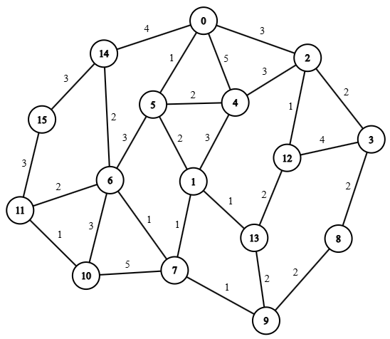

- Consider the undirected graph from Problem 2. Answer the following:
  - The size of the graph:
  - The maximum size of the graph:
  - The shortest path between 3 and 1, considering the edge’s cost:
  - The BFS traversal order (the less expensive edges are followed first):
  - The DFS traversal order (the less expensive edges are followed first):

- Represent the undirected graph from Problem 8 using an adjacency list. To facilitate the representation, use the table below to store the nodes in your linked list. Cells with -- are considered empty memory. Remember that the weight must be stored with the vertex. Use the pair {neighbor, weight} to represent the edge, and store the edge sorted by weight. Follow the model.
0 | {5, 1}-> | {2, 3}-> | {14, 4}-> | {4, 5}-> | NULL | -- | --
1
2
3
4
5
6
7
8
9
10
11
12
13
14
15

